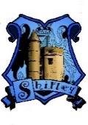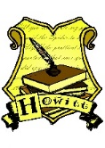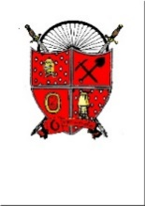

**Aldercar High School**

Daltons Close

Langley Mill

Nottinghamshire

NG16 4HL

Please apply online [MyNew](http://www.TES.com)Term

For more information contact Mrs C Prescott

[Tel: 01773 712477](Tel:01773712477)

Email: info@aldercarhigh.co.uk

**Cover Manager**

|  |  |
| --- | --- |
| **Salary and Scale:** | Grade 7 |
| **Hours per week:** | 37hrs x 39wks |

|  |
| --- |
| Aldercar High School offers brand new facilities in which students flourish and staff develop, all within a welcoming and vibrant atmosphere. We are a caring employer which prioritises the welfare and work/life balance of our staff.  We are part of the Embark Federation Trust and enjoy positive and collaborative partnerships with other schools within the Trust, including opening up new opportunities for promotion. We have already seen successful apprentices move on to become valued, permanent members of staff.  We are looking to appoint a Cover Manager.  The role of the Cover Manager is to oversee the effective day-to-day deployment of cover supervisors and /or agency personnel, to provide administrative support across the school and provide classroom supervision to students when a teacher is absent.  The ideal candidate will be reliable and responsible and manage a small team of Cover Supervisors.  Due to this post having access to children and/or vulnerable adults, the successful candidate will be required to undertake a Disclosure and Barring Service check. The possession of a criminal record will not necessarily prevent an applicant from obtaining this post, as all cases are judged individually according to the nature of the role and information provided.  **Closing date: 02/06/2025**  **Interviews: 06/09 June 2025** |

 