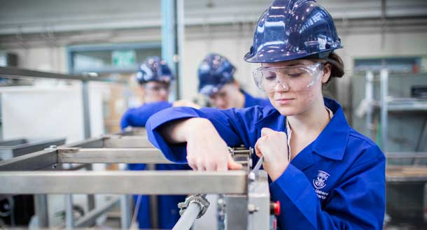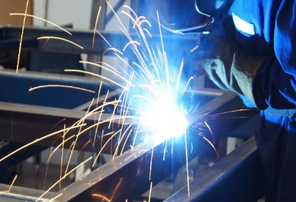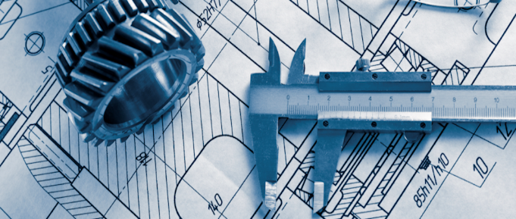

**Engineering Manufacture Level 1/2 Award/Certificate - J832, J842**

There are many career opportunities following the study of Engineering.

On completion of this course pathways to level 3 are open as is direct entrance to

apprenticeship, employment or further education.

Mechanical Engineering, CAD, Civil Engineer/Architecture and many more….

Further information from:

Career Opportunities

Pathways

Assessment

Course Structure

Mr Gillies – [agillies@aldercarhigh.co.uk](mailto:agillies@aldercarhigh.co.uk)

Overview

Exam Board

R109: Engineering materials, processes and production R111: Computer-aided manufacturing

R112: Quality control of engineered products

This qualification forms part of a suite of qualifications, which have been developed to meet the Department for Education’s (DfES) requirements for high-quality, rigorous qualifications which:

* Have appropriate content for the learner to acquire core knowledge and practical skills
* Allow the qualification to be graded
* Provide synoptic assessment
* Enable progression to a range of study and employment opportunities.

This practical qualification is designed to develop a candidate’s knowledge and understanding of engineering principles and practices.

OCR Cambridge Nationals

Subject

Exam Board

Further information

From: llllllflllll

Click Here to insert Header Picture